Web 2 - Assignment Lab - Dice Roll Simulation

Specs: Simulate the roll of an input number of dice. Use a randomly-generated number to simulate the roll of each single die and remember that JavaScript counts from zero. Hint: use two methods of the Math object, Math.random() and Math.floor(), to randomly generate an integer between 1 and 6 inclusive.

*** Remember to follow specs! ***

Input:

- Prompt user for their first name storing it in a variable called fName and validate that fName is not empty. Re-prompt until a name is entered. Note that the prompt boxes may look a little different in various browser which is ok.

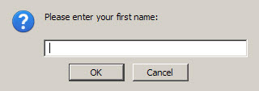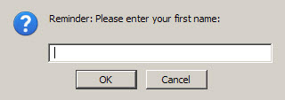

- Prompt user for the number of dice to be included in the roll storing it in a variable called numDice. Re-prompt if the entered number of dice is not a number, or not an integer greater than zero. Use the isNaN(numDice) function to see if it is not a number. Then, compare the results of parseFloat(numDice) and parseInt(numDice) to each other. If they are not equal, then numDice is not an integer. Then simply check if numDice is less than or equal to zero. If any of these checks are true, you need to re-prompt for numDice.

- Note that these checks should be done in a certain order to be efficient, yet correct and also note the wording of the messages in the prompt boxes shown below.

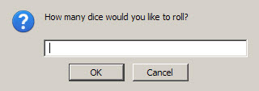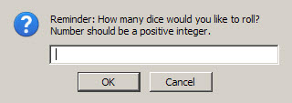

Output has two parts and should look like the following:

Part 1: One alert box for each die displaying what the value of each die roll was:

Example:



Part 2:
Display to the web page via document.write() how many dice were rolled, the value of each die, and the grand total of the dice once their values are added together. Note the use of commas and the word “and” below in the examples depending on how many dice were rolled. Use decision-making logic to determine what the case is for the current number of dice.

When only one die is rolled there should be no commas or “and” around the die value.

When two dice are rolled there should be no comma separating the two die values, but the word “and” should be between them. When three or more dice are rolled there should be commas after each die value except the last one and the word “and” should be between the last two die values following a comma.

Do NOT use arrays in your logic. You will need to use either string concatenation to build your output string or output as you have information to build on previous output.

***Also, when looking at the three output example cases below, try to find the pattern in the output of the die value(s). Use the pattern to come up with your decision logic for determining when a die value needs to be followed by a comma or preceded by the word “and”.

Use the example message format shown below:

Example (one die):



Example (two dice):



Example (three or more dice):



Reminder: do NOT use arrays in this program

Submit your dieRoll_yourUsername.html, dieRoll_ yourUsername.css and dieRoll_ yourUsername.js files in a zipped folder named dieRoll_yourUsername.

